The University Of Azad Jammu & Kashmir

Student Name: Sakeena Bano
Roll No: 2024-SE-29
Course Title: Software construction & Development
Course Code: SE-3101
Course Instructor: Engr. Dr. Asma Javaid

LAB:01

LAB 1: ONLINE TICKET RESERVATION SYSTEM

1. Introduction
The Online Ticket Reservation System allows users to book tickets online without visiting a ticket counter. Users can search for tickets, select seats, enter passenger details, make payments, and receive booking confirmations.

2. Purpose of the Use Case Diagram
The UML Use Case Diagram illustrates the system's main functions and the actors who interact with them. Rectangles represent the system boundary, ovals represent functions, and stick figures represent actors.
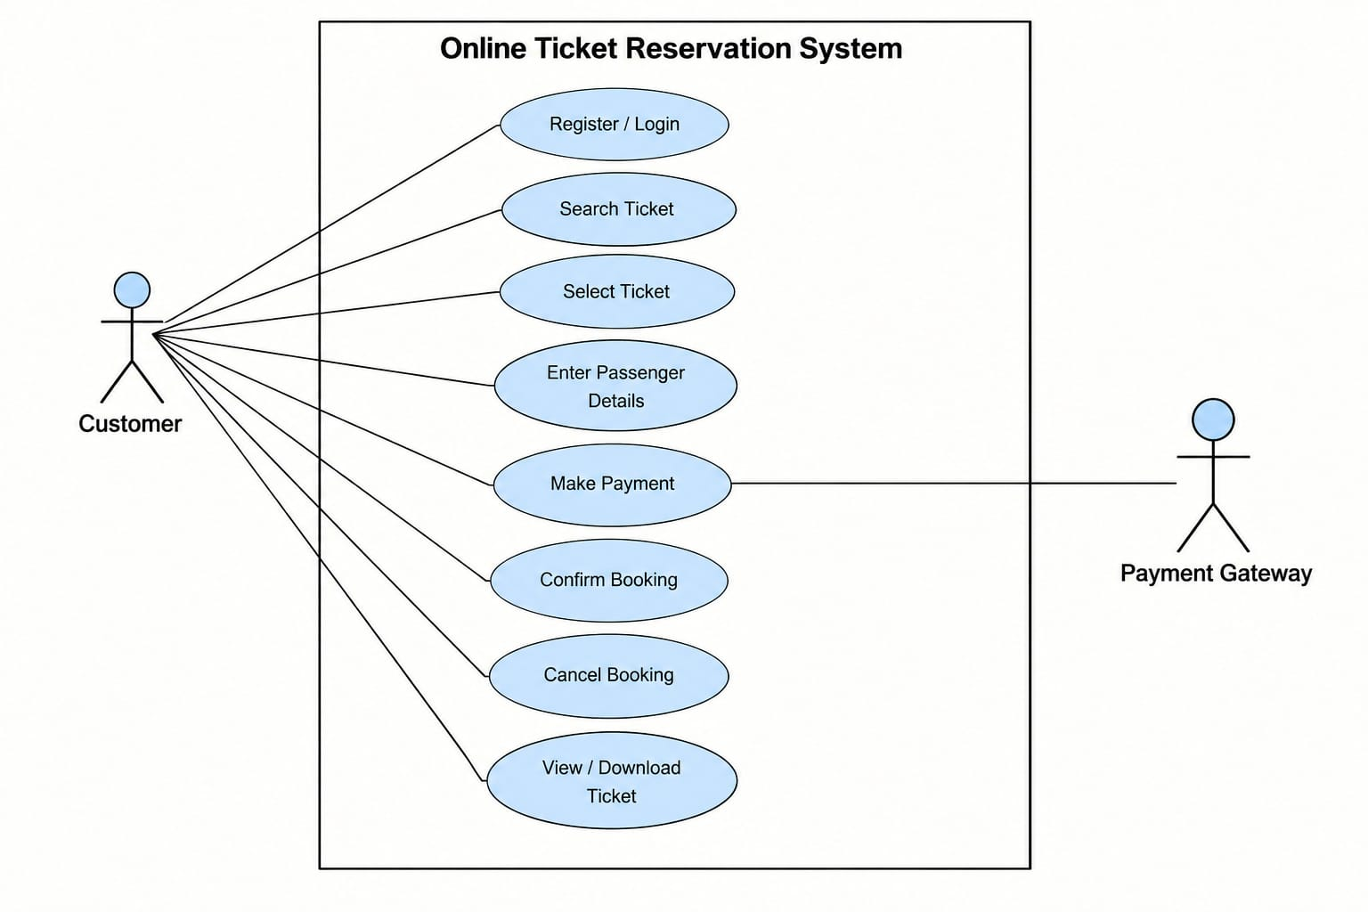

CREDIT CARD PROCESSING SYSTEM

1. Introduction
The Credit Card Processing System allows customers to pay for products and services using credit cards. It helps vendors prepare bills, process payments, and provide receipts.
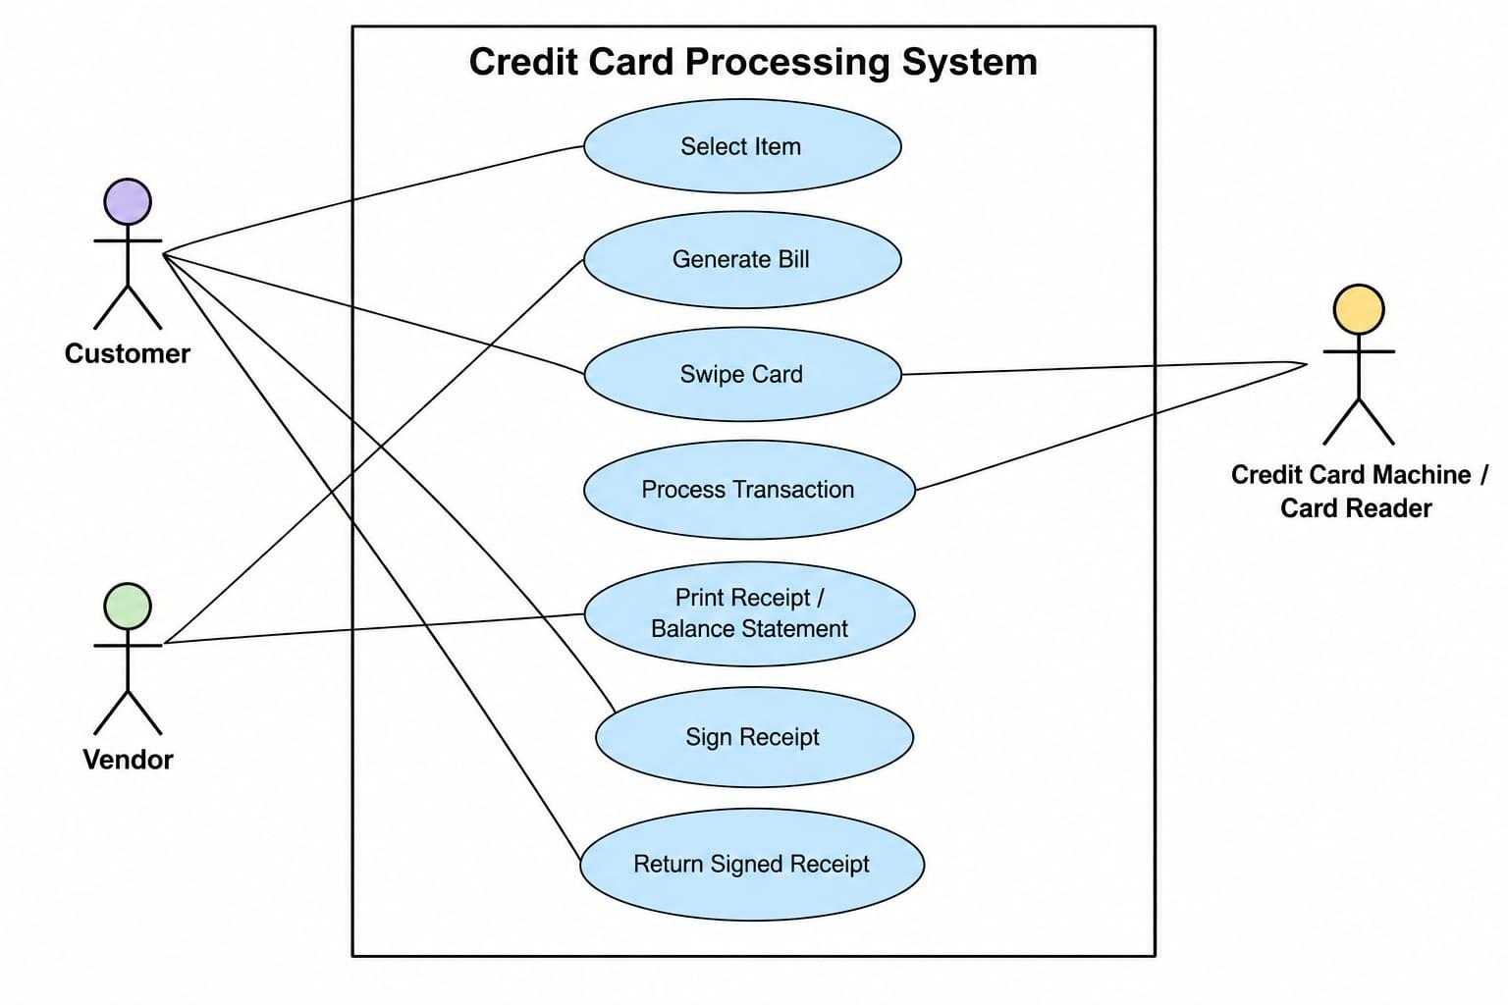

2. Objectives
- Enable convenient credit card payments.
- Generate bills automatically.
- Read credit card information.
- Process and verify transactions.
- Generate receipts and maintain payment records.

3. Actors of the System
Customer: Selects items, pays using a credit card, and signs the receipt when required.
Vendor: Prepares bills, initiates payments, and provides receipts to customers.
Card Reader: Reads card information and sends payment details for processing.

4. Use Cases
1. Select Item: The customer chooses the products or services they want to purchase.
2. Generate Bill: The system calculates the total cost of the selected items.
3. Swipe Card: The customer presents their card to the card reader.
4. Process Transaction: The payment system verifies the transaction and approves or declines the payment.
5. Print Receipt: The system generates a receipt containing transaction details.
6. Sign Receipt: The customer signs the receipt if required.
7. Return Signed Receipt: The signed receipt is returned to the vendor for record-keeping.

5. Working Procedure
- The customer selects products or services.
- The vendor prepares the bill.
- The customer presents their credit card.
- The system processes the payment.
- The transaction is approved or declined.
- A receipt is generated after successful payment.
- The receipt is signed and returned when required.

6. System Boundary
The system boundary separates internal system functions from external actors. The customer, vendor, and card reader interact with the system to complete payment activities.

7. Importance of the System
The system makes payments faster and more convenient. It reduces dependence on cash, improves billing accuracy, and maintains transaction records.

8. Advantages
- Fast and convenient payments.
- Accurate bill calculations.
- Reduced cash handling.
- Organized transaction records.
- Improved payment verification.
- Easier business accounting.

9. Conclusion
The Credit Card Processing System provides an organized way to handle electronic payments. It connects customers, vendors, and card readers to complete purchases efficiently while supporting payment verification and receipt management.

